Classification Task: Predicting Diabetes Risk

Introduction
Diabetes is a chronic condition that affects millions worldwide, requiring early diagnosis and management to mitigate complications. Machine learning techniques provide an efficient way to predict diabetes risk using patient health metrics. This report explores a step-by-step approach to building machine learning models to classify diabetes presence (positive or negative) based on health data.
The Pima Indians Diabetes Dataset from the UCI Machine Learning Repository serves as the basis for this analysis. We will preprocess the data, explore feature relationships, and implement three classification models: Logistic Regression, Random Forest, and Support Vector Machine (SVM). Each model is evaluated to understand its strengths, weaknesses, and suitability for this task.
Objectives
- Understand the Dataset: Examine data structure, missing values, and distributions of key features.
- Preprocess Data: Handle missing values and normalize features.
- Model Building: Train Logistic Regression, Random Forest, and SVM models.
- Model Evaluation: Compare models using metrics such as accuracy, precision, recall, and F1-score.
- Visualization: Use confusion matrices and ROC curves for better interpretability.
Tools Used
- Python Libraries: pandas, numpy, seaborn, matplotlib, scikit-learn.
- Models: Logistic Regression, Random Forest, and SVM.
- Evaluation Metrics: Confusion Matrix, Classification Report, ROC Curve, and AUC.

Dataset Overview
Dataset Source
The dataset used is the Pima Indians Diabetes Dataset, sourced from the UCI Machine Learning Repository. It consists of 768 records, each representing a patient's health data and diabetes status (positive or negative).
Features
Feature Name | Description | Type
Pregnancies | Number of pregnancies | Numeric
Glucose | Plasma glucose concentration (mg/dL) | Numeric
BloodPressure | Diastolic blood pressure (mm Hg) | Numeric
SkinThickness | Triceps skinfold thickness (mm) | Numeric
Insulin | 2-hour serum insulin (mu U/ml) | Numeric
BMI | Body Mass Index (kg/m²) | Numeric
DiabetesPedigreeFunction | Diabetes pedigree function | Numeric
Age | Age of the patient | Numeric
Outcome | Diabetes status (1 = Positive, 0 = Negative) | Binary
Dataset Characteristics
- Type: Binary classification task.
- Samples: 768 individuals.
- Classes: 2 (Diabetes: Positive = 1, Negative = 0).

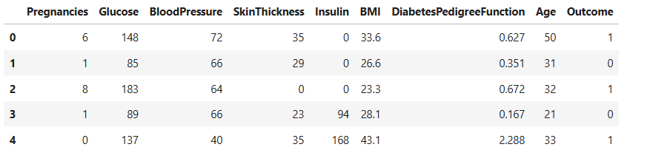

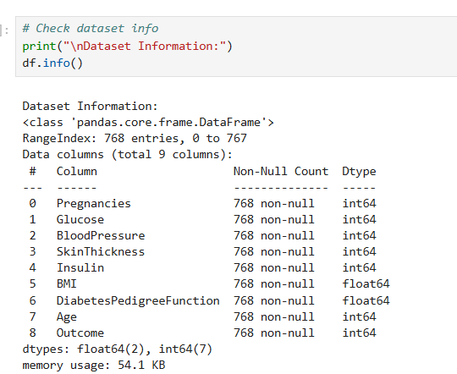

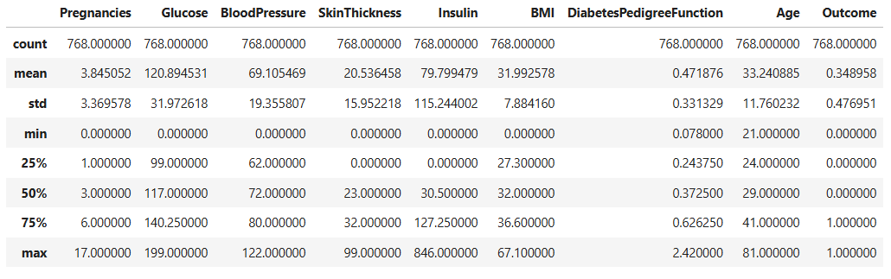

1. Data Exploration
Data exploration is the first step to understand the dataset, identify missing or invalid values, and determine feature relationships.
Steps:
- Preview the dataset to verify its structure.
- Check for missing or biologically invalid values (e.g., 0 blood pressure).
- Visualize relationships between features and the target variable (Outcome).

Missing Values
Many features (e.g., Glucose, BMI) have zero values that are biologically improbable. These are treated as missing values and replaced with the column's median.

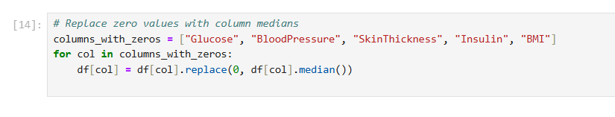

Exploring Pairwise Relationships
Pairwise relationships are visualized to detect patterns and trends in the data. For example:
- Glucose vs. Outcome: High glucose levels are often associated with a positive diabetes diagnosis.
- BMI vs. Outcome: Higher BMI values may indicate increased diabetes risk.

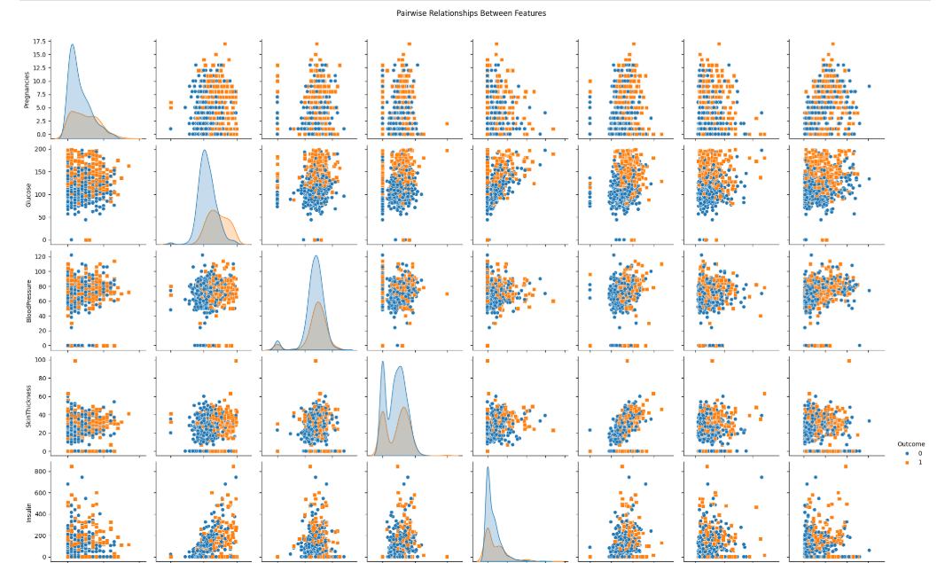

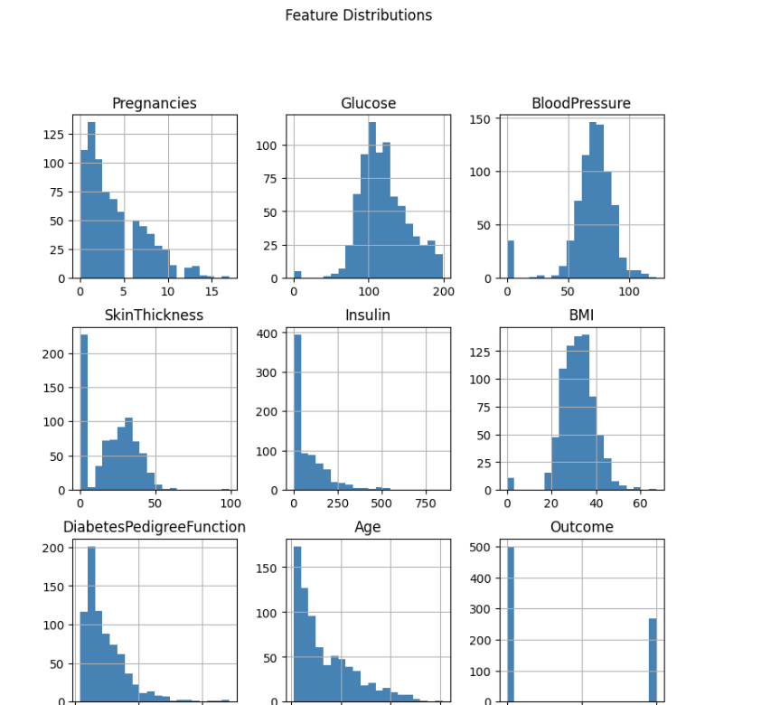

Correlation Analysis
A correlation heatmap is used to quantify relationships between features:
- Glucose and Outcome typically show a strong positive correlation.
- Features like Age and SkinThickness may show weaker correlations.

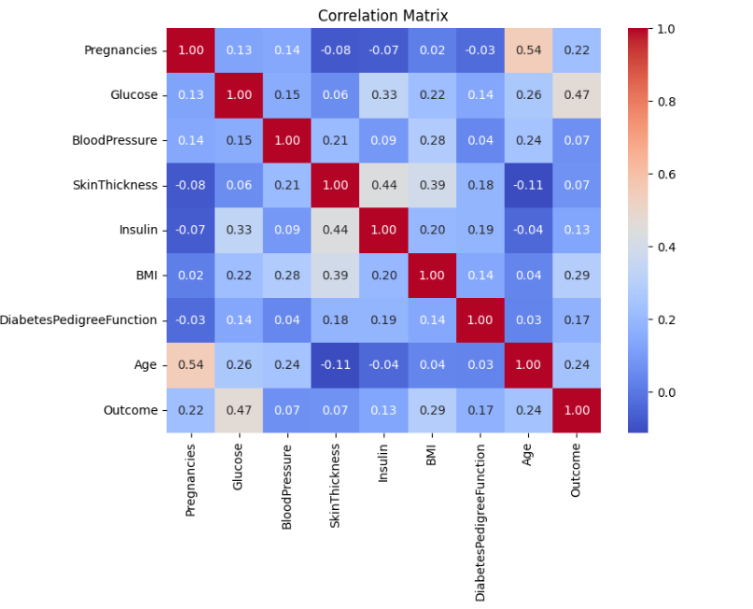

2. Data Preprocessing
Preprocessing ensures that the data is clean and suitable for machine learning models.

Feature Scaling
Features like Glucose and BMI have different ranges, which can skew model performance. StandardScaler is applied to normalize these features, ensuring that all values are on a comparable scale.

Train-Test Split
The dataset is split into:
- Training Set (80%): Used to train models.
- Testing Set (20%): Used to evaluate model performance.

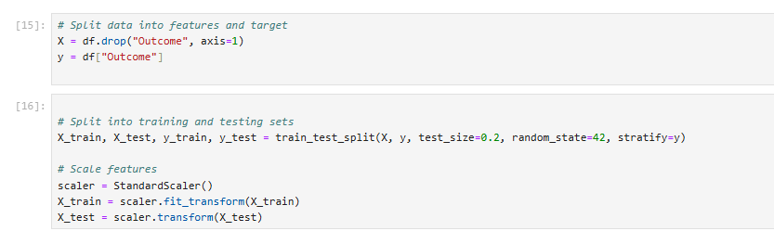

3. Model Building
Logistic Regression
Logistic Regression is a simple and interpretable baseline model that predicts the probability of a binary outcome.
Steps:
- Initialize the Logistic Regression model.
- Train the model on the training set.
- Predict diabetes status for the test set.
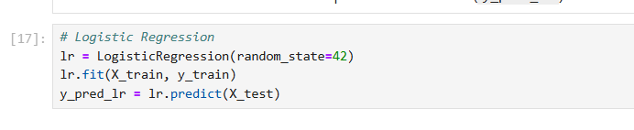
Random Forest
Random Forest is an ensemble method that uses multiple decision trees to improve classification accuracy and robustness.
Steps:
- Initialize the Random Forest model with 100 trees (n_estimators=100).
- Train the model on the training set.
- Predict diabetes status for the test set.
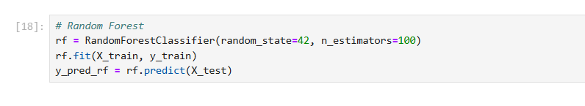
Support Vector Machine (SVM)
SVM finds the optimal hyperplane to separate data points in a high-dimensional space.
Steps:
- Initialize the SVM model with probability=True for ROC curve evaluation.
- Train the model on the training set.
- Predict diabetes status for the test set.
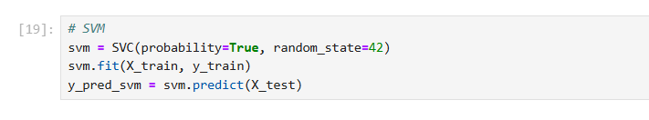
4. Model Evaluation
Evaluation Metrics
- Accuracy: Percentage of correct predictions.
- Precision: Proportion of true positives among predicted positives.
- Recall: Proportion of true positives among actual positives.
- F1-Score: Harmonic mean of precision and recall.
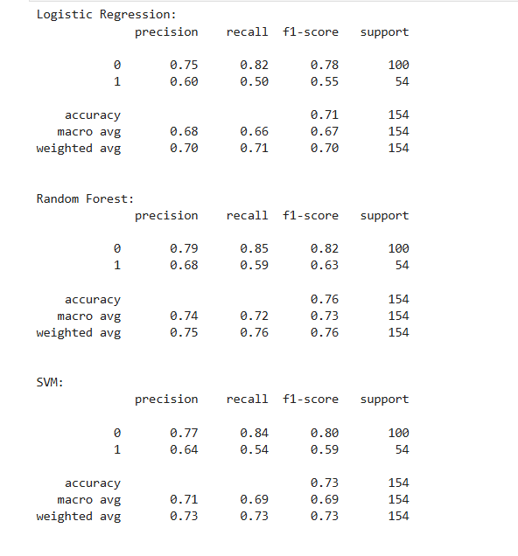

Confusion Matrices
Confusion matrices visualize the performance of each model in terms of:
- True Positives (TP): Correctly predicted positive cases.
- False Positives (FP): Incorrectly predicted positive cases.
- True Negatives (TN): Correctly predicted negative cases.
- False Negatives (FN): Incorrectly predicted negative cases.

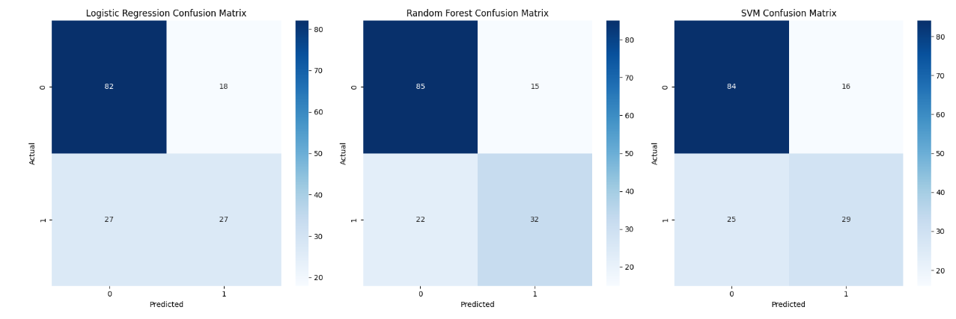

ROC Curve and AUC
The Receiver Operating Characteristic (ROC) curve shows the trade-off between sensitivity and specificity. The Area Under the Curve (AUC) quantifies the overall performance of each model.
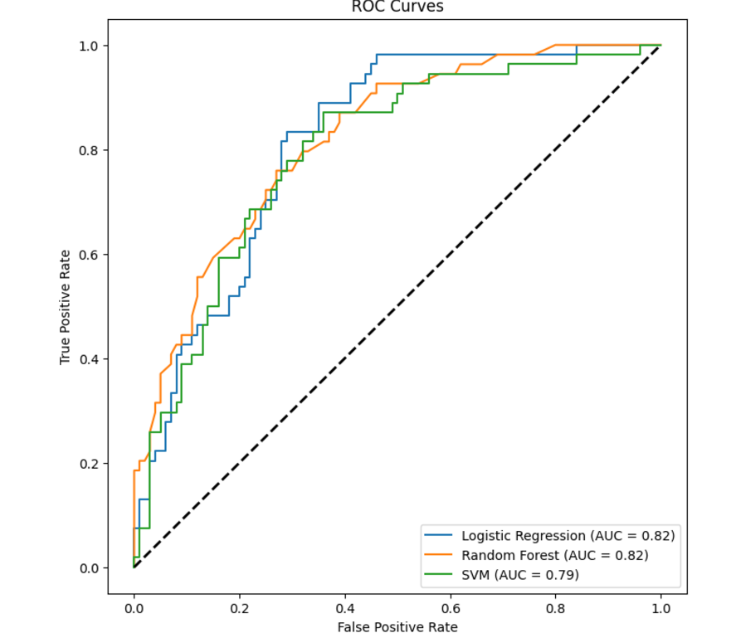
5. Results and Discussion
Performance Summary
Model | Accuracy | Precision | Recall | F1-Score | AUC
Logistic Regression | 0.707792 | 0.600000 | 0.500000 | 0.545455 | 0.815185
Random Forest | 0.759740 | 0.680851 | 0.592593 | 0.633663 | 0.820000
Support Vector Machine (SVM) | 0.733766 | 0.644444 | 0.537037 | 0.585859 | 0.793889
Key Observations
- Logistic Regression provides a strong baseline but struggles with non-linear relationships.
- Random Forest achieves higher recall, making it more suitable for imbalanced datasets.
- SVM captures complex decision boundaries and performs well on scaled data.

6. Conclusion
Key Takeaways
- Data Exploration: Features like Glucose and BMI are strongly correlated with diabetes risk.
- Preprocessing: Replacing zero values and scaling features significantly improve model performance.
- Model Comparison:
  - Logistic Regression: Best for baseline analysis.
  - Random Forest: Robust and effective for imbalanced datasets.
  - SVM: Excels in capturing non-linear patterns but requires scaling.
Future Directions
- Apply advanced models like Gradient Boosting or XGBoost.
- Address class imbalance using oversampling techniques like SMOTE.
- Perform hyperparameter tuning for all models.

References
- Harrison, J., et al. (2023). UCI Machine Learning Repository: Pima Indians Diabetes Dataset. Retrieved from UCI Repository.
- Pedregosa, F., et al. (2011). Scikit-learn: Machine Learning in Python. Journal of Machine Learning Research, 12, 2825–2830.
- Chollet, F. (2017). Deep Learning with Python. Manning Publications.

